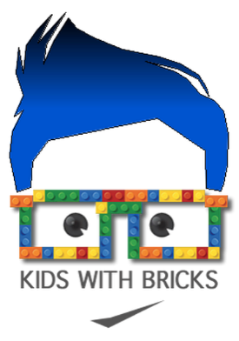

Dear Parents,

Kids With Bricks After School Club- Wray Common Primary School (Thursday)

We are pleased to be able to offer a new Kids With Bricks after school club running from 15:15-16:15 every Thursday for 6 weeks from 16th April 2026. This club is open for Years 1-3 and there are a maximum of 20 places available. The club is organised, administered and supported by Kids With Bricks Ltd, an external provider who deliver after school clubs across the whole of the UK.

As well as completing a range of exciting educational challenges, students will have the chance to work both individually and to work in teams.
As an added bit of fun, students from the club will also take part in a weekly inter-school competition where parents can vote for their favourites and points are won for the national leader board.

BOOK ONLINE!
The club costs £4.50 +VAT per child per session and is paid for half termly in advance. All club places are reserved and paid for online. Just go to www.kidswithbricks.com to book your child’s place.

Summer Term 1 2026 Tickets are live on our website from Wednesday 18th March midday.

Any questions please contact us at bookings@kidswithbricks.com
Kind regards,

Kids With Bricks

