
Phone: 07557 351405 Email: flexiflics@gmail.com Website: www.flexiflics.co.uk

Before School Gymnastics at Wray Common School
Our sessions will run on a Monday and Tuesday before school in the school hall.
The children will come in through the school office and go straight to class after gymnastics.
Your child will need to wear sports appropriate clothing (pe kit or leggings/shorts)
PLEASE NOTE: Your child will not be allowed to join in, just in the school skirt/dresses. Shorts will be required underneath.

Monday will be for Year 3-6 from 7:45-8:30am
Tuesday will be for Year 1 and 2 from 7:45-8:30am

The dates for this term are:
Monday 13th April – Monday 6th July 2026
The 9-week course will be at a cost of £65.25
(excluding half term, bank holidays and Inset Days)

Tuesday 14th April – Tuesday 7th July 2026
The 12-week course will be at the cost of £87.00
(Excluding half term)

Flexi Flics welcomes all gymnasts of all levels, whether they are a complete beginner or have done gymnastics before. Our sessions are fun, challenging and engaging. Our main goal is to build our gymnasts confidence while teaching them different gymnastics skills in a safe and friendly environment. We aim to encourage all levels of gymnasts and help them to improve their balance, coordination, flexibility, as well as encouraging them to do the best they can. Our sessions are based around the Winstrada award scheme, where each gymnast will work towards achieving badges and certificates to show their progress.
Please note: Children who already attend gymnastics will also need to resign up again for the new term.
Our sessions are run on a first come, first served basis. If you would like to sign up to the before-school session, we ask that you contact Flick directly, where she will send you a link to fill out our online registration form.
Once the form is complete Flick will be in contact regarding payment to secure your space. Please note, spaces are not secure until payment has been received. Once payment has been received please note fees are non-refundable.
Please feel free to like our Flexi Flics Facebook page for updates on holiday sessions and our external classes.
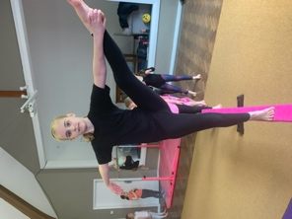
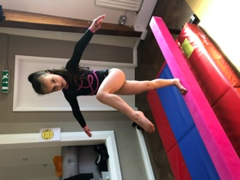
Flick and The Flexi Flics Team

