
Purple Mash: A guide
How to log on:
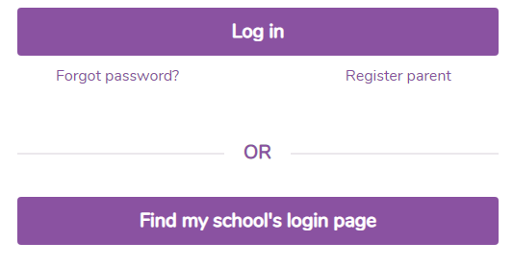
Open your web browser and type www.purplemash.com
Click on Find my school’s login page and search for Wray Common.
Now login using your username and password.
You should now see the Purple Mash home page.

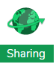
How to access the daily blog:
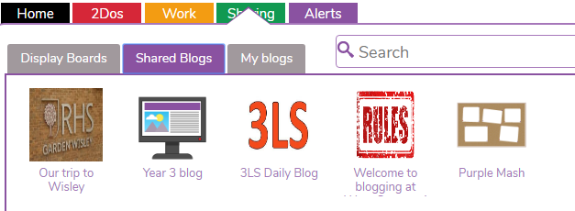
Each class has a daily blog. These can be access by clicking on the ‘Sharing’ tab
Once you have clicked on the Class Blogs tab, you should see your class daily blog. This is where you will be set your tasks each day.

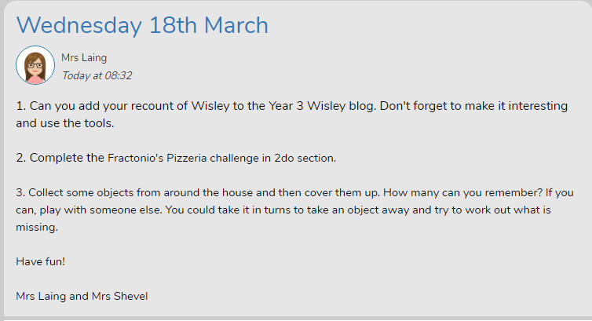
Some tasks will require the children to use the 2do section on Purple Mash.
Some tasks will not require children to use a computer or tablet.
Make sure you click on the date to ensure you see the whole post.

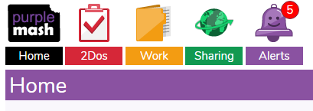
How to access and complete 2do tasks:
.
To access 2do tasks, you need to click on 2do from the Purple Mash homepage.

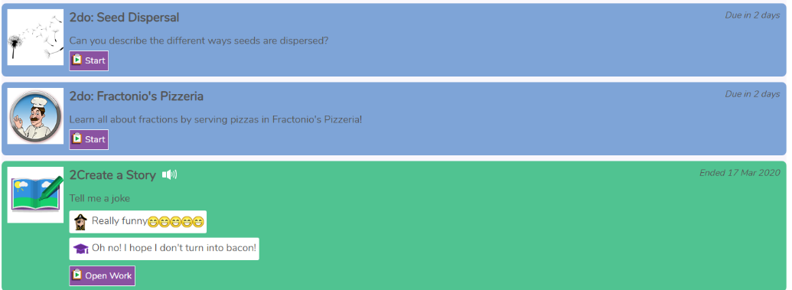
Tasks that are to be done through Purple Mash will show here.
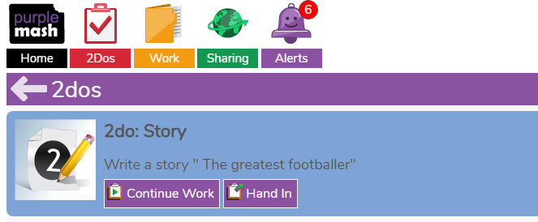
Blue tasks are current tasks. Tasks turn green when the deadline for completion has ended.

Once completed, children should click ‘Hand in’.
Children do not have to finish their work in one sitting. Once started, work can be saved and access from the 2do section until the deadline ends.

