Purple Mash: A guide
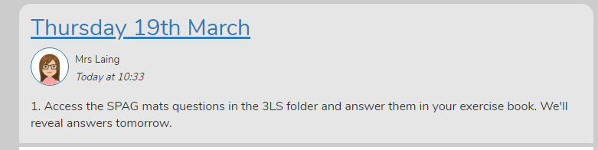
How to access supporting documents:
The daily blog might ask children to access a supporting document such as a sheet of maths or SPAG questions. This does not need to be printed off but can be read and children could respond in their exercise books.

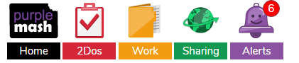
To access the document click on the work tab.

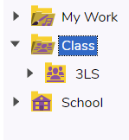
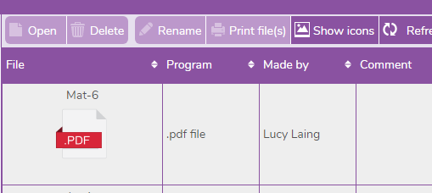
Click on the class tab and your class.

The document will be listed.

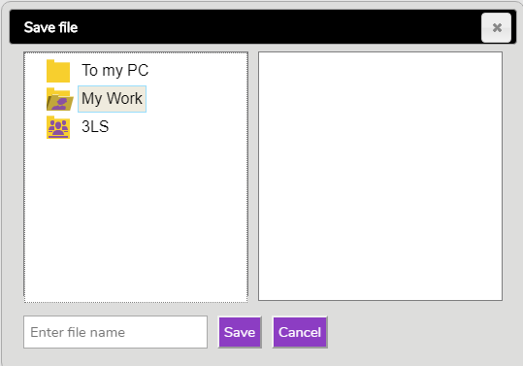
How to save activities / work created independently
There are lots of games and activities to explore on Purple Mash.
If you create your own work, remember to save it in your personal ‘My Work’ folder rather than the class folder.

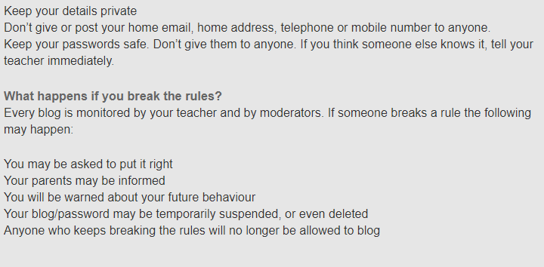
Wray Common Blogging rules
